1) Exercice 1
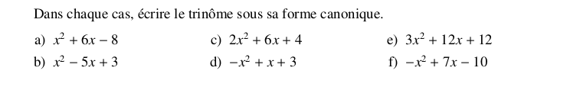
2) Exercice 2

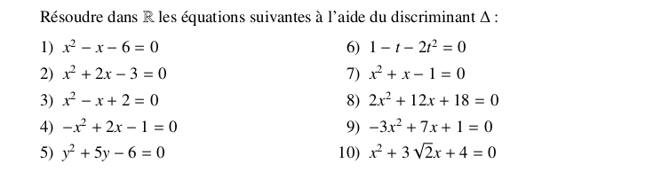
3) Exercice 3

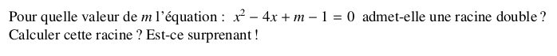
4) Exercices 4

